ARBURG at NPE 2024
Hybrid Allrounder 520 H produces high-quality moulded parts from ABS recyclate

- Hybrid: Energy saving, efficient, low acquisition costs and carbon footprint
- Sustainable: Exhibit reliably processes plastic recyclate
- Economical: New hybrid machine technology

Lossburg, 07/03/2024
At NPE 2024, a hybrid Allrounder will demonstrate how ABS recyclate can be processed into high-quality moulded parts and returned to the material cycle. The exhibit from the Hidrive series is equipped with Arburg's new hybrid machine technology, which is not only excellent at saving energy and conserving resources, but is also efficient in production, user-friendly and reliable. This allows users to harness the benefits of both electric and hydraulic technology – namely speed and precision paired with power and dynamics.

Arburg's finely graduated hybrid machine technology is comparable to all-electric machines in terms of dry cycle times and injection speeds. This makes the new Allrounder Hidrive (H) an energy-saving alternative to hydraulic machines and an economical alternative to electric machines, unlike anything previously available on the market.

ABS recyclate returned to the cycle
At NPE 2024, an Allrounder 520 H "Premium" with a clamping force of 1,500 kN will be processing 100 per cent recycled ABS from SEG, made from recycled washing machines, dryers and refrigerators. A 1+1+1-cavity family mould is used to produce a machine base, feed hopper and controller on a scale of 1:18 in a cycle time of around 50 seconds. These are then separated from each other in a cutting station and complete a 15-part set for a model Allrounder. A Multilift Select V 8 linear robotic system removes the moulded parts and sets them down in a box. A box changer provides around two hours of autonomy.

Sensor controlled mould monitoring
The "aXw control ReferencePilot" control assistant and a pressure sensor ensure that the holding pressure is regulated very precisely based on the pressure profile in the mould and that fluctuating material viscosity is compensated for. The result is high-quality moulded parts with similar properties to those made from virgin material, but with a significantly smaller carbon footprint.
In this application, the Moldlife Sense computer system enables sensor-controlled mould monitoring over the complete life cycle. The recorded data is passed via an OPC-UA interface directly to the Gestica control system, which displays corresponding malfunctions as well as performance-dependent maintenance intervals, thereby enabling predictive maintenance.

Cost- and resource-saving alternative
The Hidrive series combines an electric energy-efficient and precise clamping unit with a powerful and dynamic hydraulic injection unit. It is characterised by attractive purchase and operating costs as well as a very good energy balance and carbon footprint.
A novelty in the new hybrid Allrounder "Premium" machines is flow splitting as standard, with cutting-edge Varan valve technology used to split the main pump's available flow volume when required. This enables simultaneous movements of hydraulic auxiliary axes with programmable control such as the ejector and core pull – without technology stages or multi-pump technology. This saves energy, costs and space on the machine and increases production efficiency.
Thanks to a new oil management concept, the Allrounder machines require up to around 35 per cent less oil. The required cooling water capacity can be reduced by up to 70 per cent and the dry cycle time is also reduced by around 40 per cent.

Three performance variants for optimal adaptation
The hybrid Allrounder Hidrive is currently available in sizes 470, 520 and 570 and in three performance variants: "Comfort", "Premium" and "Ultimate". The first two variants feature the Arburg servo hydraulic system (ASH) as standard, with the speed-controlled, water-cooled servo motor adapting continuously to the actual power requirement, thus enabling particularly energy-efficient and low-emission operation. At the same time, however, the machine's cooling requirements and noise level are also significantly reduced.
The "Premium" performance variant achieves dry cycle times of 1.2 seconds and can be used for a wide range of applications such as the production of precision components for the automotive and electronics industries. Its standard equipment includes a planetary roller screw drive and the Arburg electro-mechanical dosage (AED) function for longer dosage times.
The "Ultimate" variant is specially designed for high-speed and sophisticated processes. AED is included as standard equipment here too, alongside hydraulic accumulator technology, which ensures a constant pressure level. The result: quick, dynamic simultaneous movements and more process setting options. The Gestica control system with "aXw Control ScrewPilot" function compensates for errors in the filling process and keeps the mould filling stable. All together, this provides for a level of injection precision equivalent to that of an electric injection unit.

Photos

194798
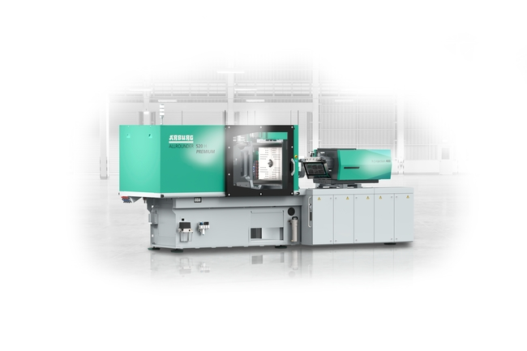
The "Premium" performance variant of the hybrid Allrounder 520 H combines a precise clamping unit with planetary roller screw drive and an injection unit with Arburg servo hydraulics (ASH).

196315
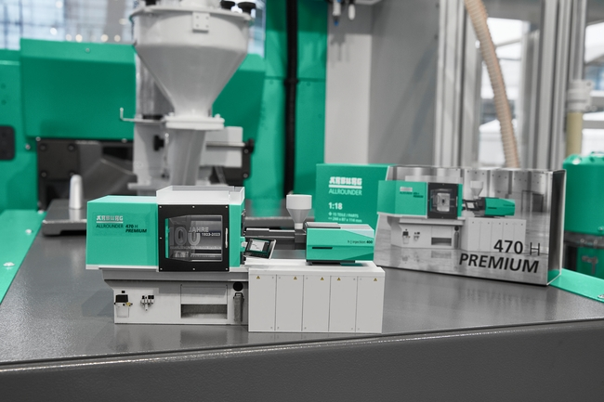
At NPE 2024, an Allrounder 520 H "Premium" will be using 100 per cent ABS recyclate to produce three components of a 15-piece set for a model Allrounder on a scale of 1:18.

Photos: ARBURG
Photo download:
media.arburg.com/web/3e35c629d6f1fee2/allrounder-520h-npe-2024

Press release
File: ARBURG Press release Allrounder 520 H NPE 2024_en_GB.docx
Characters: 4,785
Words: 714

This and other press releases are available for download from our website at www.arburg.com/de/presse/ (www.arburg.com/en/press/)

Contact
ARBURG GmbH + Co KG
Press office
Susanne Palm
Dr Bettina Keck
Postfach 1109
72286 Lossburg
Tel.: +49 (0)7446 33-3463
Tel.: +49 (0)7446 33-3259
presse_service@arburg.com

About Arburg
German family-owned company Arburg is one of the world's leading manufacturers of plastic processing machines. Its product portfolio encompasses Allrounder injection moulding machines with clamping forces of between 125 and 6,500 kN, the freeformer for industrial additive manufacturing and robotic systems, customer and industry-specific turnkey solutions and further peripheral equipment.
Arburg is a pioneer in the plastics industry when it comes to energy and production efficiency, digitalisation and sustainability. The "arburgXworld" program comprises all digital products and services and is also the name of the customer portal. The company’s strategies regarding the efficient use of resources and circular economy, as well as all related aspects and activities, are outlined in the 'arburgGREENworld' program.
Arburg's main aim is to enable its customers to manufacture their plastic products, from one-off parts to large-volume batches, to optimum quality standards and in a way that conserves resources, is sustainable and minimises unit costs. Target groups include the automotive and packaging industries, communication and entertainment electronics, medical technology and the white goods sector.
First-class customer support on-site is guaranteed by the international sales and service network: Arburg has own organisations in 26 countries at 36 locations and is represented in over 100 countries together with trade partners. Its machines are produced at the company's German headquarters in Lossburg. Of a total of roughly 3,700 employees, around 3,100 work in Germany, with another 600 employees based in Arburg's organisations around the world. Arburg is certified to ISO 9001 (quality), ISO 14001 (environment), ISO 27001 (information security), ISO 29993 (training) and ISO 50001 (energy).
Further information about Arburg can be found at www.arburg.com

