Arburg exhibit at Fakuma 2023
Allrounder 920 H: turnkey system makes toolboxes in the Arburg design

- Efficient: flexible turnkey system based around a hybrid Allrounder 920 H
- In demand: toolbox in the stylish Arburg design
- Sustainable: processing of ISCC-certified PC/ABS and recyclate from PET films

Lossburg, 17/10/2023
In a live demonstration, a hybrid Allrounder 920 H with a clamping force of 5,000 kN produce the main components of the much sought-after toolbox in the Arburg design at Fakuma 2023. The turnkey system also includes a Scara robot integrated into the machine controller, a Multilift V linear robot system and an innovative tool carrier facility. The high-quality plastic product will be completed by hand and the stylish toolbox handed out to the trade fair visitors.

Over-moulded 3D films and hot-stamped Arburg lettering help create the high-grade aesthetics of the meticulously designed giveaway. The centre section, handle, closing clips and the feet were likewise pre-manufactured at Arburg in Lossburg on Allrounders.

Automated: robotic systems work hand-in-hand
Film inserts positioned on workpiece carriers are fed into the production cell by a double sliding table. A KUKA Scara robot, programmable via the Gestica control system, prepares the pre-produced film inserts and places them on a centering station to suit the cavity spacings of the mould. A linear robot system then comes into play: the Multilift V 40 picks up the inserts, moves past an ionisation bar, which cleans them, and inserts them into the 1+1-cavity injection mould. Here, they undergo in-mould lamination in the insert moulding process. The two moulded parts are then removed. The raised Arburg lettering on the top shell is refined inline in a hot stamping station, and this is discharged together with the bottom shell via a conveyor system. The innovative tool carrier facility is combined with a manual workstation outside the turnkey system, on which the toolbox is completed with its centre section, handle, locking clips and feet.

Sustainable: biomaterials and recyclate from PET films
A sustainable, biomass-balanced and ISCC-certified PC/ABS from Covestro is processed for the main components. The case closures and handles are created from components made of Recopound® from Arburg partner Leonhard Kurz. This material is extracted from post-industrial recyclate (PIR) on the basis of PET films. It uses up to 40 percent less CO₂ than new materials. For homogeneous material processing and consistently high product quality, the exhibit is equipped with Arburg’s recyclate package, which includes hardware and software elements.

"Intelligent" assistance systems
"Intelligent" Gestica assistants provide active support at the machine. The "aXw Control FillAssist" function is networked with Simcon’s Varimos plug-in for filling simulation in the control system itself. With the help of this AI-supported variant analysis from Cadmould, the injection moulding simulation is automated with the FillAssist and "learns" which effects the machine parameter changes have. Another assistance function for this application is the "aXw Control EnergyAssist" for optimised switching on and off of all heating zones. The, "aXw Control PressurePilot" ensures bionically optimised pressure regulation. As an addition to the recyclate package, the adaptive process control works with the "aXw control RecyclatePilot" feature to create a stable shot weight.
(Application video: https://youtu.be/z9LZoK_Q9HM)

Photos

184507
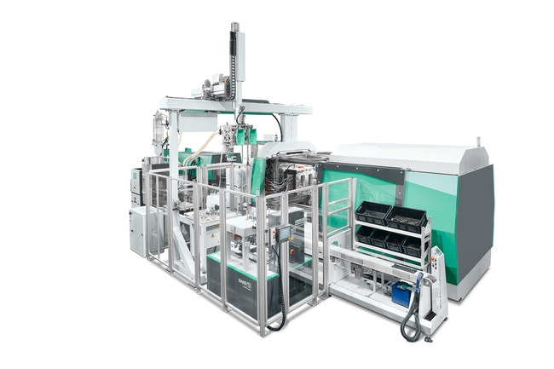
A flexible turnkey system based around a hybrid Allrounder 920 H produces the main components of the much sought-after toolbox in the Arburg design at Fakuma 2023.

184312
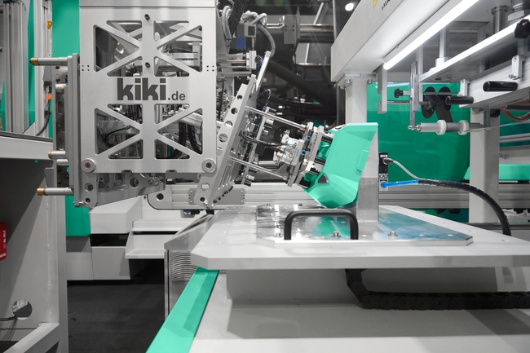

A Scara robot and a Multilift V 40 linear robot system handle the toolbox halves.

183282

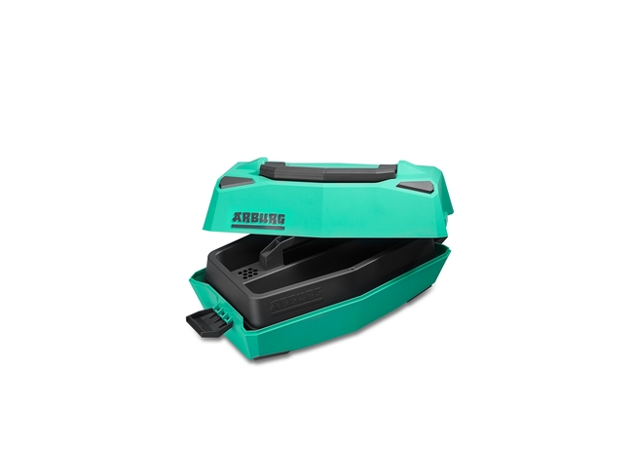

Stylish toolbox: over-moulded 3D films and hot-stamped Arburg lettering provide the high-grade aesthetics.

Photos: ARBURG

Photo download – updated with motifs from the trade fair:
https://media.arburg.com/portals/downloadcollection/2C76064B4E176AC36388B580CFC60947

Press release
File: 08 ARBURG press release Allrounder 920H toolbox Fakuma 2023_en_GB.docx
Characters: 3,247
Words: 492

This and other press releases are available for download from our website at www.arburg.com/de/presse/ (www.arburg.com/en/press/)

Contact
ARBURG GmbH + Co KG
Press office
Susanne Palm
Dr Bettina Keck
Postfach 1109
72286 Lossburg
Tel.: +49 (0)7446 33-3463
Tel.: +49 (0)7446 33-3259
presse_service@arburg.com

About Arburg
German family-owned company Arburg is one of the world's leading manufacturers of plastic processing machines. Its product portfolio encompasses Allrounder injection moulding machines with clamping forces of between 125 and 6,500 kN, the Freeformer for industrial additive manufacturing and robotic systems, customer and industry-specific turnkey solutions and further peripheral equipment.
Arburg is a pioneer in the plastics industry when it comes to energy and production efficiency, digitalisation and sustainability. The "arburgXworld" program comprises all digital products and services and is also the name of the customer portal. The company’s strategies regarding the efficient use of resources and circular economy, as well as all related aspects and activities, are outlined in the 'arburgGREENworld' program.
Arburg's main aim is to enable its customers to manufacture their plastic products, from one-off parts to large-volume batches, to optimum quality standards and in a way that conserves resources, is sustainable and minimises unit costs. Target groups include the automotive and packaging industries, communication and entertainment electronics, medical technology and the white goods sector.
First-class customer support on-site is guaranteed by the international sales and service network: Arburg has own organisations in 26 countries at 36 locations and is represented in over 100 countries together with trade partners. Its machines are produced at the company's German headquarters in Lossburg. Of a total of roughly 3,800 employees, around 3,200 work in Germany, with another 600 employees based in Arburg's organisations around the world. Arburg is certified to ISO 9001 (quality), ISO 14001 (environment), ISO 27001 (information security), ISO 29993 (training) and ISO 50001 (energy).
Further information about Arburg can be found at www.arburg.com

