Arburg exhibit at Fakuma 2023
Allrounder 520 A: Highly innovative IML application for medical technology

- Innovative: In-mould labelling (IML) for centrifuge tubes creates added value
- Integrated: IML labels increase functionality of medical technology products
- In partnership: Joint project around high-performance electric machine

Lossburg, 17/10/2023
While in-mould labelling (IML) is standard for packaging products, this process is still rarely used in the medical industry. Using centrifuge tubes with labels as an example at Fakuma 2023, Arburg will be unveiling an innovative IML application with added value for the pharmaceutical industry and medical technology.

Renowned partners Kebo (tooling), MCC/Verstraete (label), Beck (automation) and Intravis (camera inspection) are involved in the innovative joint IML project centred around an electric Allrounder 520 A in clean room design.

Functional integration using an IML label

IML labels enable functional integration in a single step with no need for printing associated with rejects, for example, or further downstream work steps. As a result, the production process is fast, space-saving, cost-efficient and without any additional hygiene risk. The intelligent linking of data is essential for smooth digital communication between patients and doctors or home care applications. Individual codes can be used to track data on processes, quality and patients, for example, with 100 per cent traceability for each individual part. The monitoring of temperature profiles or information on recycling and warehouse management can also be implemented with these labels.

High-performance electric machines for medical technology

The exhibit, an electric Allrounder 520 A "Ultimate" with 1,500 kN clamping force, is designed for fast and demanding processes such as thin-wall applications. The high-performance machine in clean room design meets the requirements of class ISO 7. An 8-cavity mould from Kebo is used to produce 15 millilitre tubes from PP. A label applicator head from Beck is used to apply the labels, while optical control is carried out via a camera system from Intravis. The servo-electric drives of the injection moulding machine ensure precise and reproducible mould positioning. With the exhibit, attention was also paid to a low carbon footprint, energy efficiency and a compact production cell.

Further information:

https://iml.mcclabel.com/en/medical-iml-at-fakuma

Photo

194732
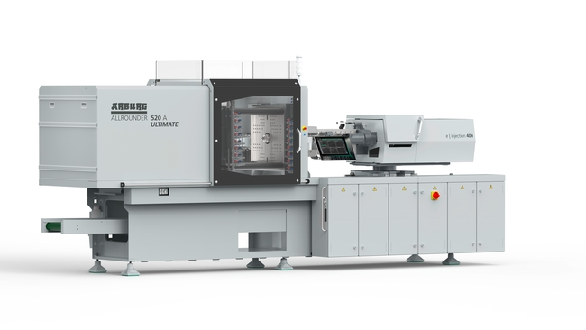
An innovative application for medical technology is demonstrated by an electric Allrounder 520 A Ultimate. The high-performance machine produces IML centrifuge tubes at Fakuma 2023 as part of a joint project.

Photo: ARBURG

Photo download – updated with motifs from the trade fair:
https://media.arburg.com/portals/downloadcollection/C651AF7E0909D11840B620453B91FC1F

Press release
File: 03 ARBURG press release Allrounder 520A IML medical Fakuma 2023_en_GB.docx
Characters: 1,9599
Words: 300

This and other press releases are available for download from our website at www.arburg.com/de/presse/ (www.arburg.com/en/press/)

Contact
ARBURG GmbH + Co KG
Press office
Susanne Palm
Dr Bettina Keck
Postfach 1109
72286 Lossburg
Tel.: +49 (0)7446 33-3463
Tel.: +49 (0)7446 33-3259
presse_service@arburg.com

About Arburg
German family-owned company Arburg is one of the world's leading manufacturers of plastic processing machines. Its product portfolio encompasses Allrounder injection moulding machines with clamping forces of between 125 and 6,500 kN, the freeformer for industrial additive manufacturing and robotic systems, customer and industry-specific turnkey solutions and further peripheral equipment.
Arburg is a pioneer in the plastics industry when it comes to energy and production efficiency, digitalisation and sustainability. The "arburgXworld" program comprises all digital products and services and is also the name of the customer portal. The company’s strategies regarding the efficient use of resources and circular economy, as well as all related aspects and activities, are outlined in the 'arburgGREENworld' program.
Arburg's main aim is to enable its customers to manufacture their plastic products, from one-off parts to large-volume batches, to optimum quality standards and in a way that conserves resources, is sustainable and minimises unit costs. Target groups include the automotive and packaging industries, communication and entertainment electronics, medical technology and the white goods sector.
First-class customer support on-site is guaranteed by the international sales and service network: Arburg has own organisations in 26 countries at 36 locations and is represented in over 100 countries together with trade partners. Its machines are produced at the company's German headquarters in Lossburg. Of a total of roughly 3,800 employees, around 3,200 work in Germany, with another 600 employees based in Arburg's organisations around the world. Arburg is certified to ISO 9001 (quality), ISO 14001 (environment), ISO 27001 (information security), ISO 29993 (training) and ISO 50001 (energy).
Further information about Arburg can be found at www.arburg.com

